Tribute Dinner Nominating Committee
Each year the Casey Tibbs Foundation holds a Tribute Dinner to honor deserving individuals’ and families who have been involved in the world of rodeo and ranching in South Dakota. We do not consider this an induction into the Casey Tibbs South Dakota Rodeo Center because an induction is not necessary for individuals to be a part of the Rodeo Center. This is simply a way we can pay tribute to some very deserving people and help preserve the history of rodeo in our state. We do hope however, that the people we honor throughout the years will want to be a part of the Rodeo Center. Casey did not want the Casey Tibbs South Dakota Rodeo Center to become a “Hall of Fame” where people had to be inducted into to be able to be a part of. Therefore the Tribute Dinner was born.

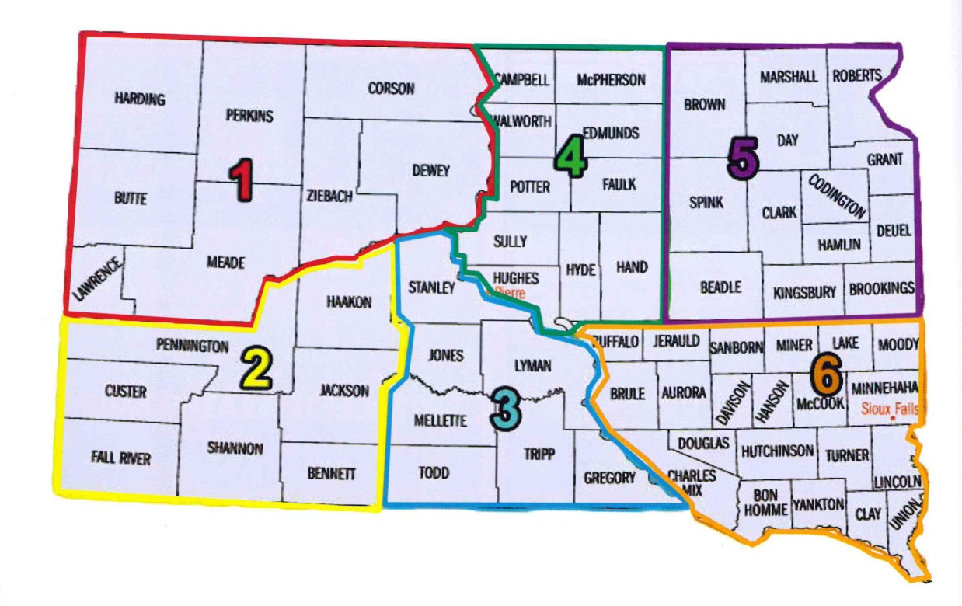
The Casey Tibbs Foundation has assembled a committee made up of individuals from across the state. We divided the state into 6 regions with 2 committee spots in each region. Each year at a meeting in August the Committee reviews all of the nominations submitted to the Casey Tibbs Foundation choosing two nominations in each category to recommend to the Casey Tibbs Foundation Board of Directors to be honored at that year’s Casey Tibbs Foundation Tribute Dinner. The Board of Directors makes the final selection from their two recommendations in each category. The six categories for nomination are:
- Rodeo Cowgirl Great 2. Rodeo Cowboy Great 3. Past Rodeo Great
4. Rodeo Promoter 5.Ranch-Cowboy Family 6. Rodeo Animal Athlete

The committee spots are two year spots, members will rotate off and new members will come on the committee. If you are interested in participating on this committee, helping to choose who we honor each year at the Casey Tibbs Tribute Dinner, please fill out the form and send it to the Casey Tibbs Foundation, PO Box 911, Fort Pierre SD 57532.

Name_______________________________________________________
Address_____________________________________________________
City__________________________ State________ Zip_______________
Phone_______________________________________________________
Rodeo Affiliation Associated With (not required)_____________________

