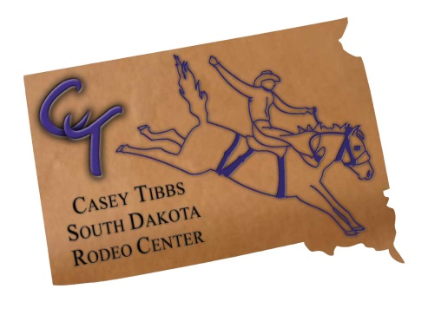
__Yes! I want to support South Dakota’s only Rodeo Museum!
Suggested donation: $50
Larger denominations welcome!

Name________________________________________________________________________
Address______________________________________________________________________
City________________________________________ State___________ Zip______________
Email_______________________________________ Phone____________________________
Check #__________________________________ Cash_______________________________
Credit Card: ___VISA ___MasterCard
#____________________________________3 digit CVV_________Expiration Date________

Please make checks to the Casey Tibbs SD Rodeo Center or (CTSDRC) and mail to:
PO Box 37, Fort Pierre, SD 57532. Please call us if you have any questions. 605-494-1094.

As you know the Casey Tibbs SD Rodeo Center operates without State or Federal Funding and relies on overhead costs and improvements to be funded by memberships, bequests and donations.
Your contribution will help ensure the stories of South Dakota rodeo and the western way of life are kept alive for generations to come!
With your $50 membership, you will receive two passes to the museum, our bi-annual newsletter and upcoming year calendar. You can also specify if you want your donation to be used for Capital Improvements or for anything else specific.
We appreciate your support!

